

## **EXPLANATION OF RESEARCH**

**Title of Study**: Data Visualization in Managerial Judgments

**Principal Investigator**: Kelly Wellman

**Faculty Supervisor**: Dr. Theresa Libby

You are being invited to take part in a research study. Whether you take part is up to you.

The purpose of this research is to examine how managers’ judgments and decisions might change when accounting information is presented visually.

All parts of this study will take place online in the location of your choice. Participants will receive the survey via an online link. In Part A of the survey, you will complete some questions measuring your money management skills and two different activities where you will be presented with a series of shapes on the screen. You will be asked to mentally rotate or “unfold” each shape and then choose a matching representation from a set of several different possibilities presented on the screen. Next, you will perform a short imagination task where you will brainstorm ideas about an object presented to you on the screen. You will type as many of those ideas as you can into a text box over a two-minute period. Then in Part B of the survey, you will view a set of graphs containing data about a hypothetical company and its products. Participants in the study will be randomly assigned to see one of four different versions of these graphs. You will use the data in the graphs to answer as many multiple-choice questions about the content of those graphs as possible in a limited amount of time. Finally, you will complete Part C of the survey, also online, containing a post-experimental questionnaire about your experiences during the study and some basic demographic information.

The study should be completed in one sitting and should take no more than 30 minutes to complete. You will receive a fixed payment of $4.00 for completing the study plus a small additional payment that varies between $0.00 and $3.20 depending on your performance on Parts A and B of the survey ($0.05 per correct answer that you provide). You can exit the study at any time but closing your web browser, but according to Prolific’s rules, you cannot be compensated unless you complete the study.

At the end of the study, you will be asked to provide your Prolific ID so that we can pay you the amounts owed. All data will be retained for a minimum of 5 years after study closure in a password-protected UCF One Drive folder.

To participate in this study, you must be a US resident, 18 years of age or older, have a basic degree of financial literacy, have some prior experience in a management position and have a minimum of 3 years of full-time work experience.

**Study contact for questions about the study or to report a problem:** If you have questions, concerns, or complaints: Kelly Wellman, PhD student, Business Administration-Accounting Track, [Kelly.Wellman@ucf.edu](mailto:Kelly.Wellman@ucf.edu), or Dr. Theresa Libby, Faculty Supervisor, Dixon School of Accounting, College of Business, [Theresa.libby@ucf.edu](mailto:Theresa.libby@ucf.edu).

**IRB contact about your rights in this study or to report a complaint:** If you have questions about your rights as a research participant, or have concerns about the conduct of this study, please contact the Institutional Review Board (IRB), University of Central Florida, Office of Research, 12201 Research Parkway, Suite 501, Orlando, FL 32826-3246 or by telephone at (407) 823-2901, or email [irb@ucf.edu](mailto:irb@ucf.edu).

I consent to participate __ yes ___ no

[items in square brackets will not be seen by the participants]

Consent form will appear here

Part A [all participants]

Thank you for agreeing to participate in this study. First, please choose the most correct response to the following questions to the best of your ability without using outside sources.

**Suppose you had $100 in a savings account and the interest rate was 2% per year. After 5 years, how much do you think you would have in the account if you left the money to grow?**

* More than $102
* Exactly $102
* Less than $102
* Do not know

**Imagine that the interest rate on your savings account was 1% per year and inflation was 2% per year. After 1 year, how much would you be able to buy with the money in this account?**

* More than today
* Exactly the same
* Less than today
* Do not know

**Please tell me whether this statement is true or false. “Buying a single company’s stock usually provides a safer return than a stock mutual fund.”**

* True
* False
* Do not know

**PAPER FOLDING TEST**  
  
Next you will answer some questions that will help me understand your spatial ability. Prior research shows that different people have different levels of spatial ability. Some people will find these questions easier while others will find them more difficult.   
  
**Please read the instructions carefully. In addition to the fixed payment of $4, you will receive a bonus of $0.05 for each correct answer that you provide.**

**<screen break here>**  
  
In this test, you are to imagine the folding and unfolding of pieces of paper. In each problem in the test there are some figures drawn on top and there are others drawn below. The figures on top represent a square piece of paper being folded, and the last of these figures has one or two small circles drawn on it to show where the paper has been punched.  
  
Each hole is punched through all the thicknesses of paper at that point. One of the five figures below shows where the holes will be when the paper is completely unfolded. You are to decide which one of these figures is correct and click the circle close to that figure.  
  
In these problems all of the folds that are made are shown in the figures on top, and the paper is not turned or moved in any way except to make the folds shown in the figures. Remember, the answer is the figure that shows the positions of the holes when the paper is completely unfolded.  
  
You will have 3 minutes for each of the two parts of this test. Each part has one page. You will not be able to go back from part 2 to part 1.

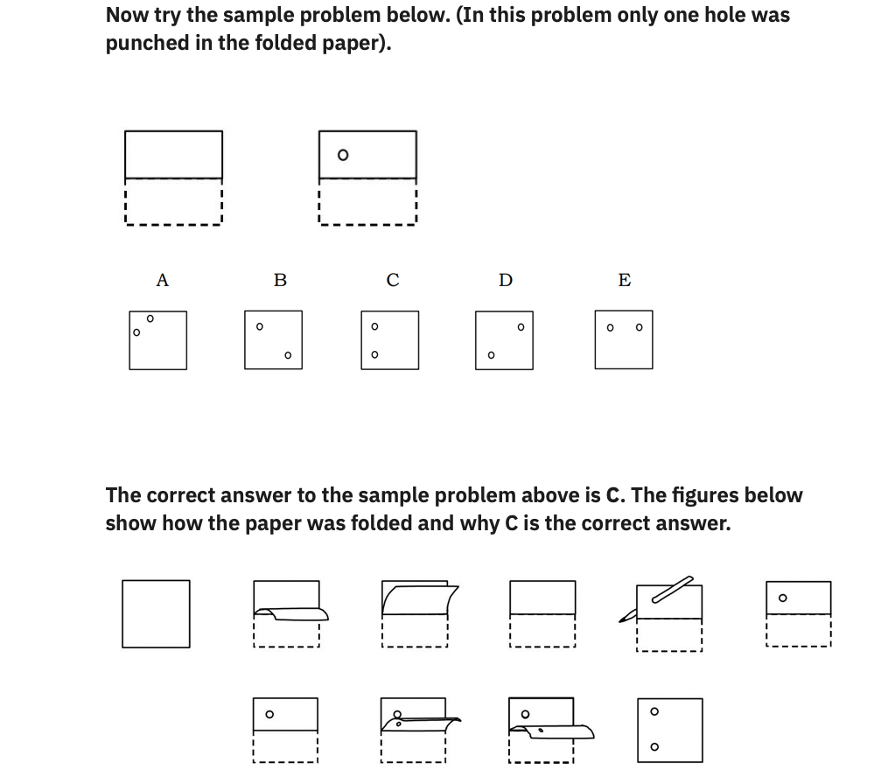

Please click **Next**when you are ready to start part 1 of the test.

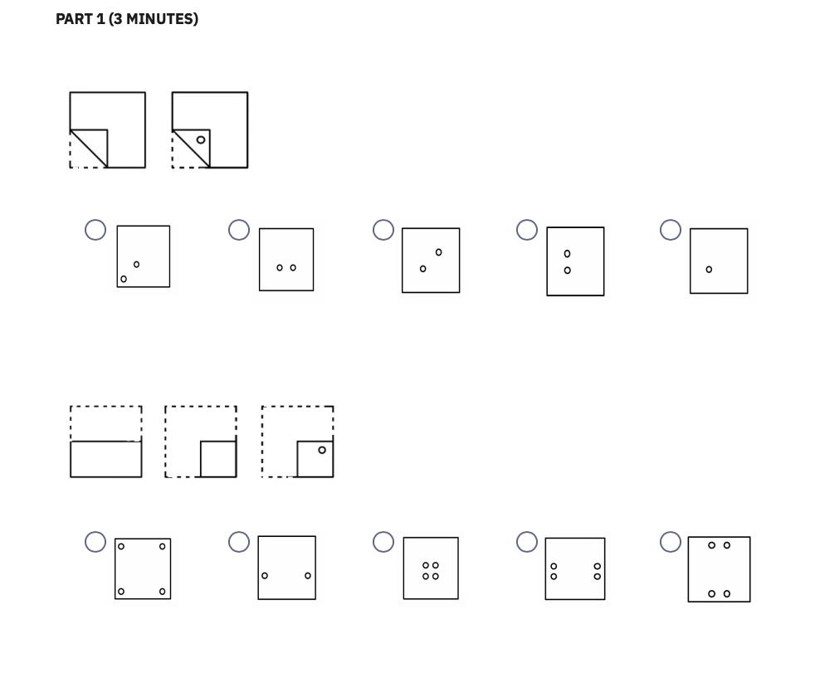 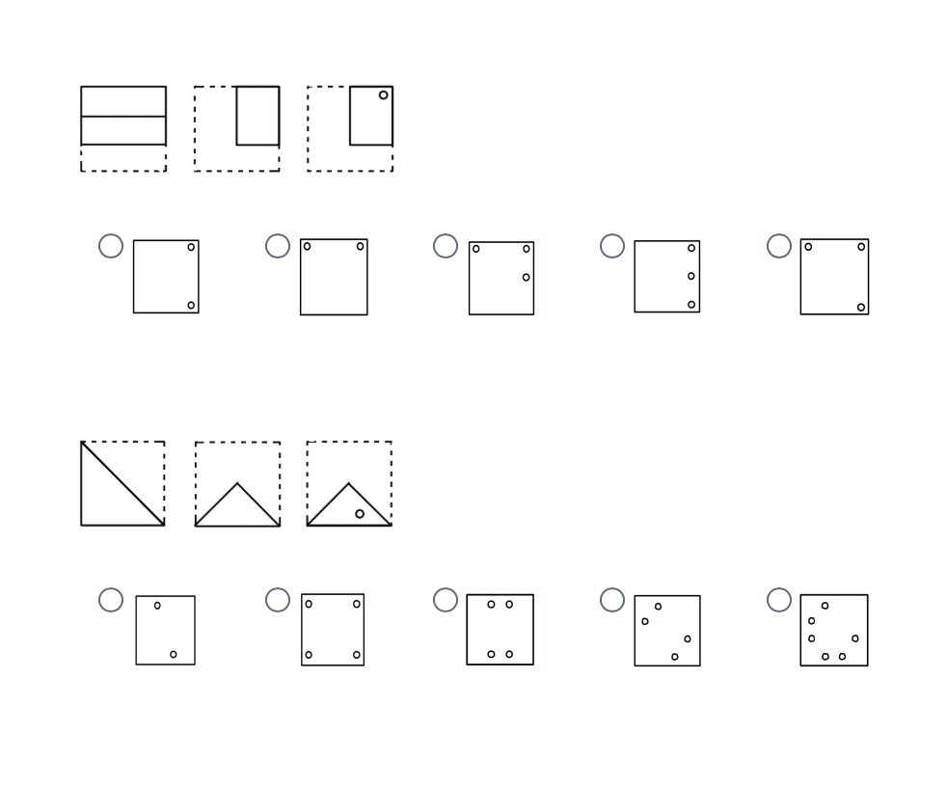 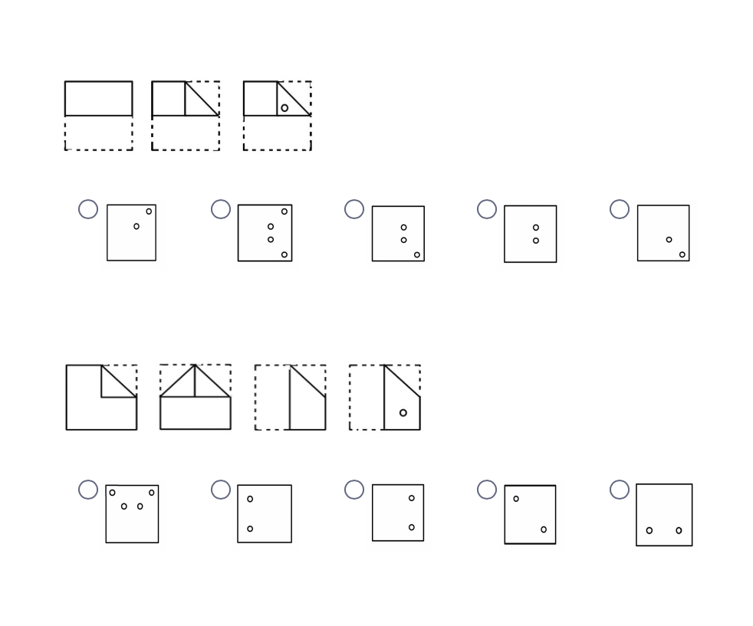 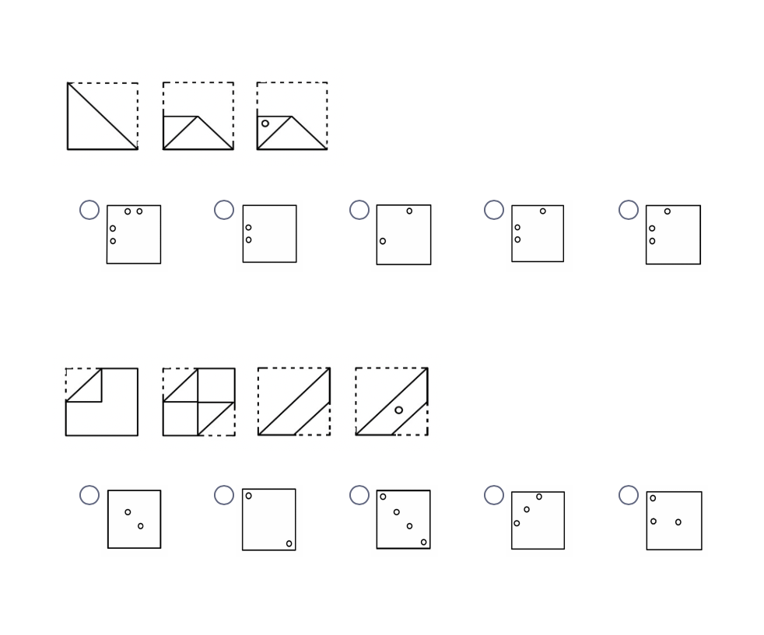 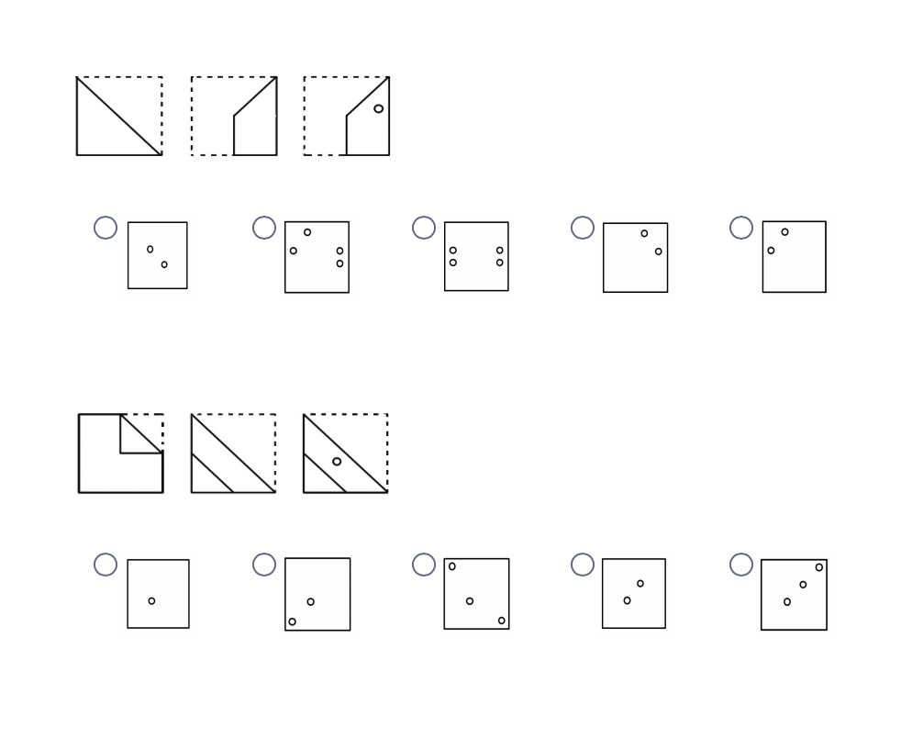

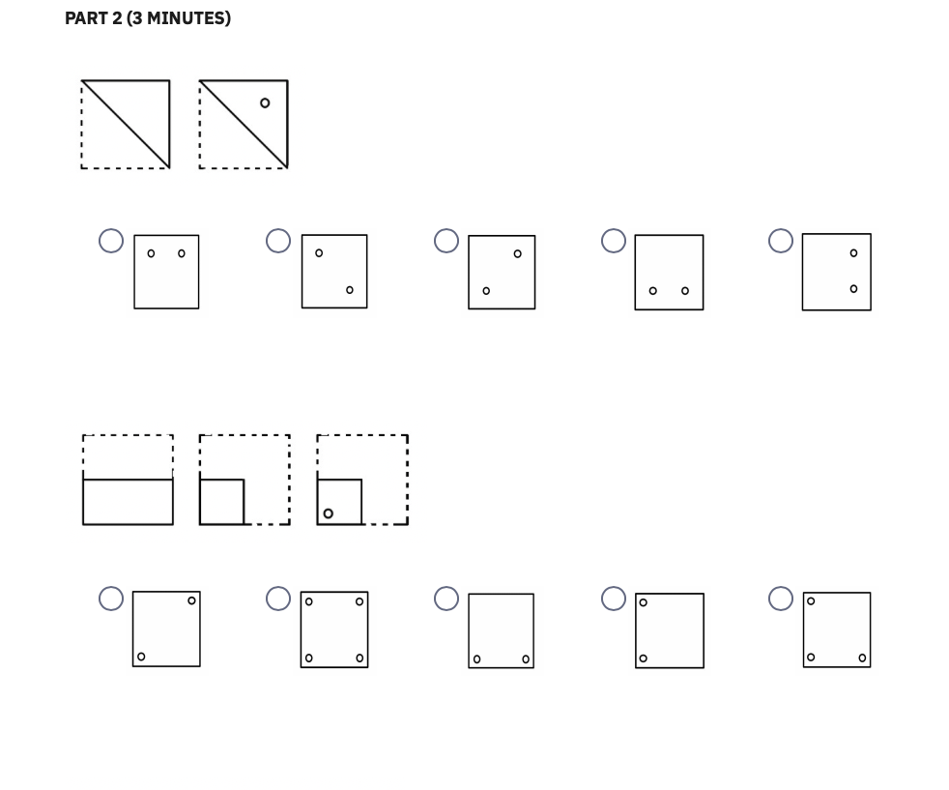 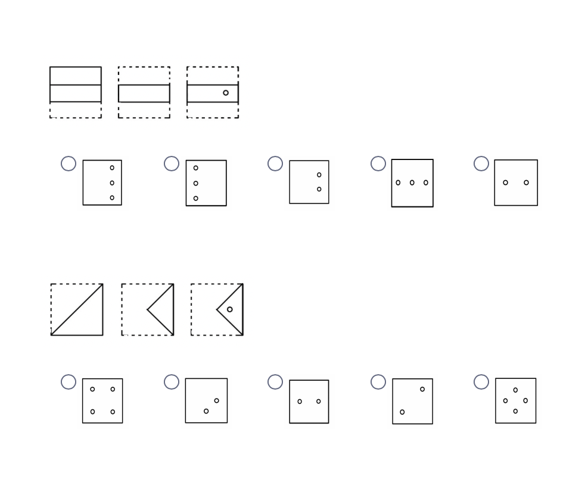 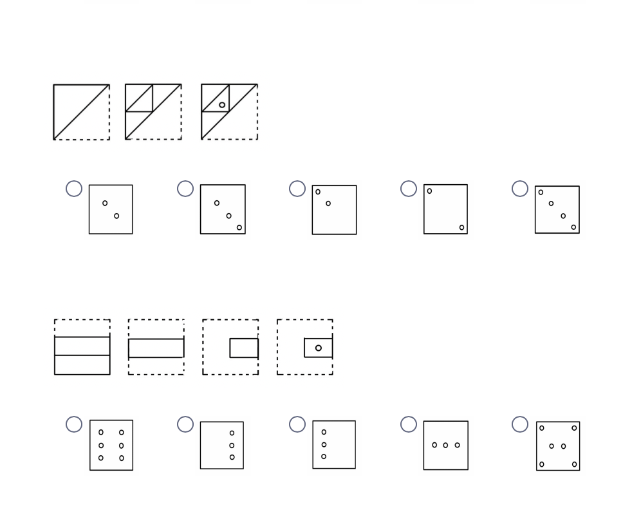 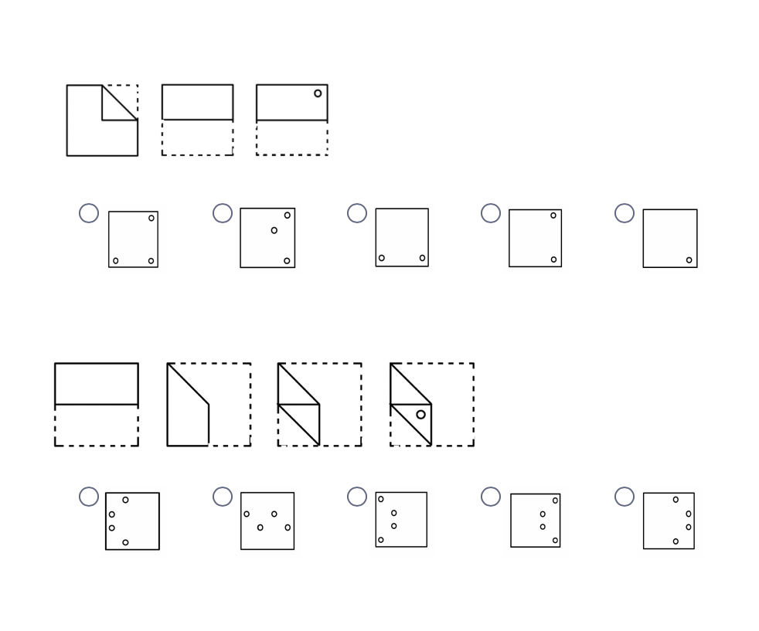 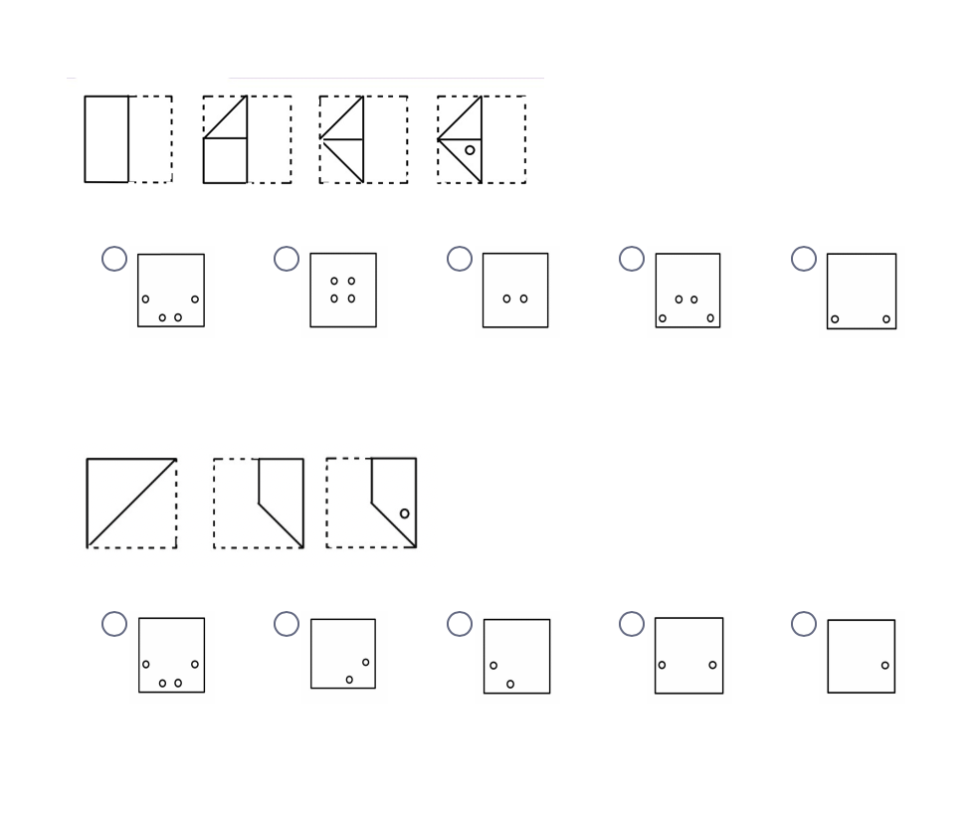

**ROTATION TEST**Thank you for your participation thus far. Next, you will answer some questions that will help me to understand a different aspect of your spatial ability. Prior research shows that there are different types of spatial ability, and these differences mean some people will find these questions easier while others will find them more difficult. Please read the instructions carefully. **In addition to the fixed payment of $4, you will receive a bonus of $0.05 for each correct answer provided below.**  
This is a test of your ability to see differences in figures. Look at the 5 triangle-shaped cards drawn below.

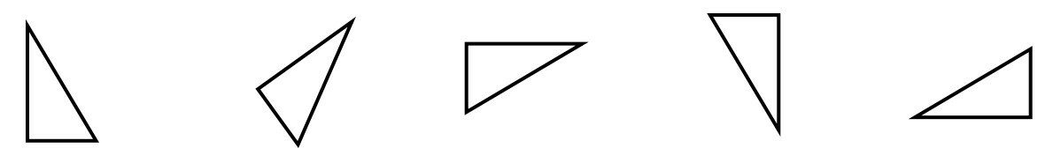

All of these drawings are of the **same** card, which has been slid around into different positions on the page.

You will have 3 minutes for each of the two parts of this test. Each part has 1 page.

Now look at the 2 cards below:  
 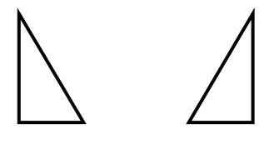

**These two cards are not alike. The first cannot be made to look like the second by sliding it around on the page. It would have to be flipped over or made differently.**

**Each problem in this test consists of one figure on top and eight below. You are to decide whether each of the eight figures below is the same as or different from the figure on top.**

**Mark the box beside Same if the figure is the same as the one on top. Mark the box beside Different if the figure is different from the one on top.**

**Practice on the following rows. The first row has been correctly marked for you.** 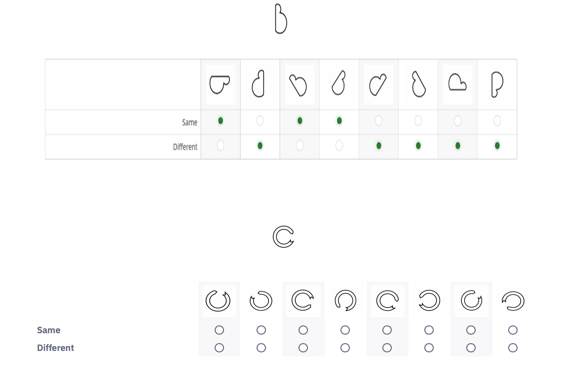 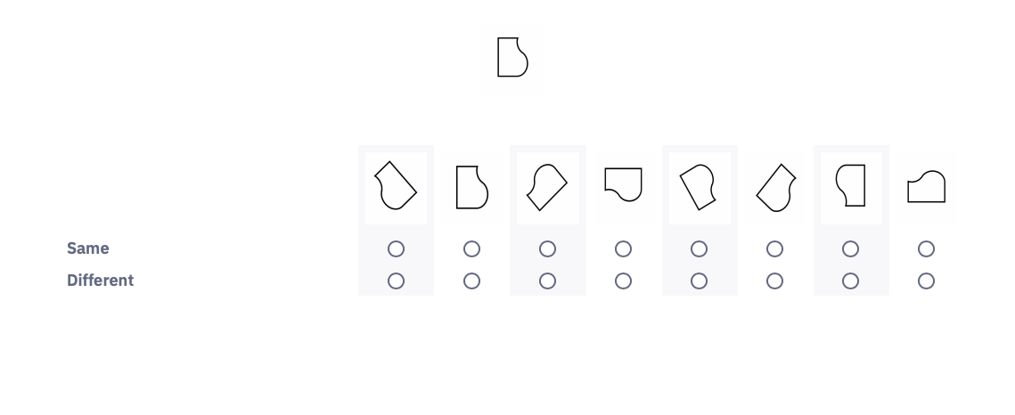

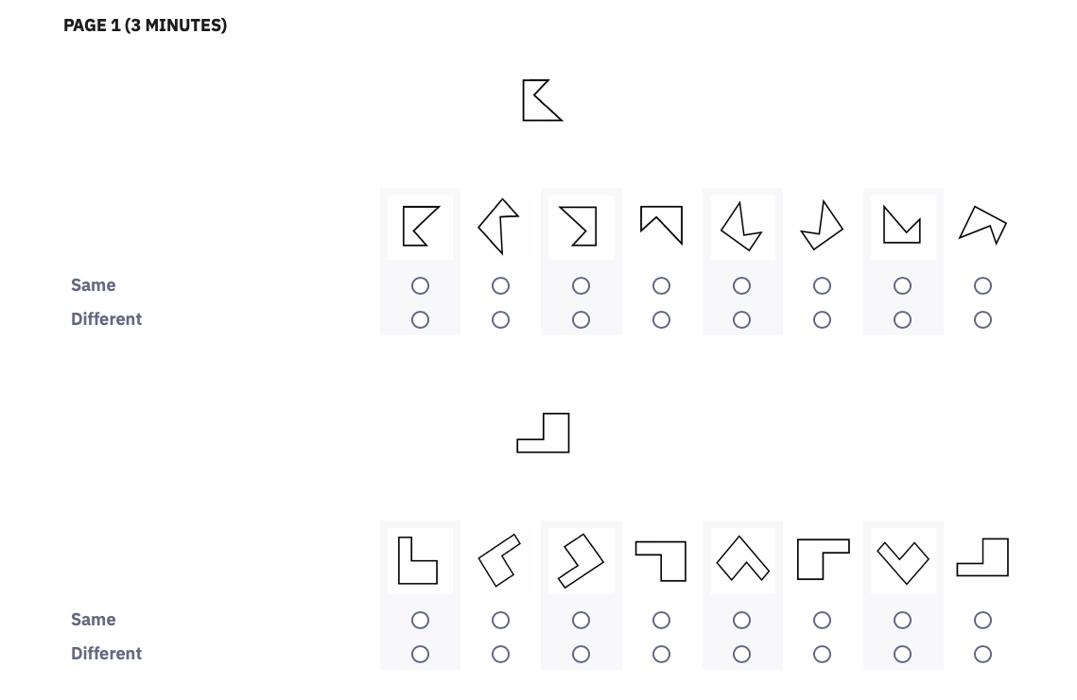 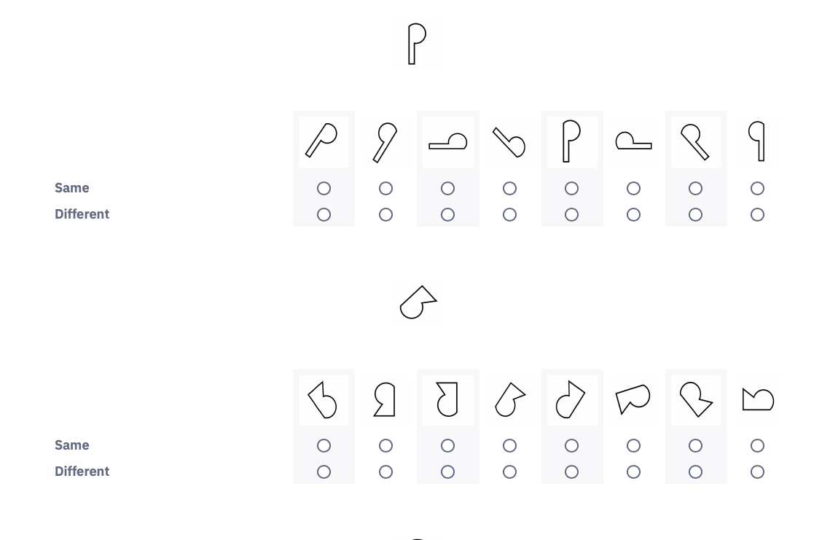 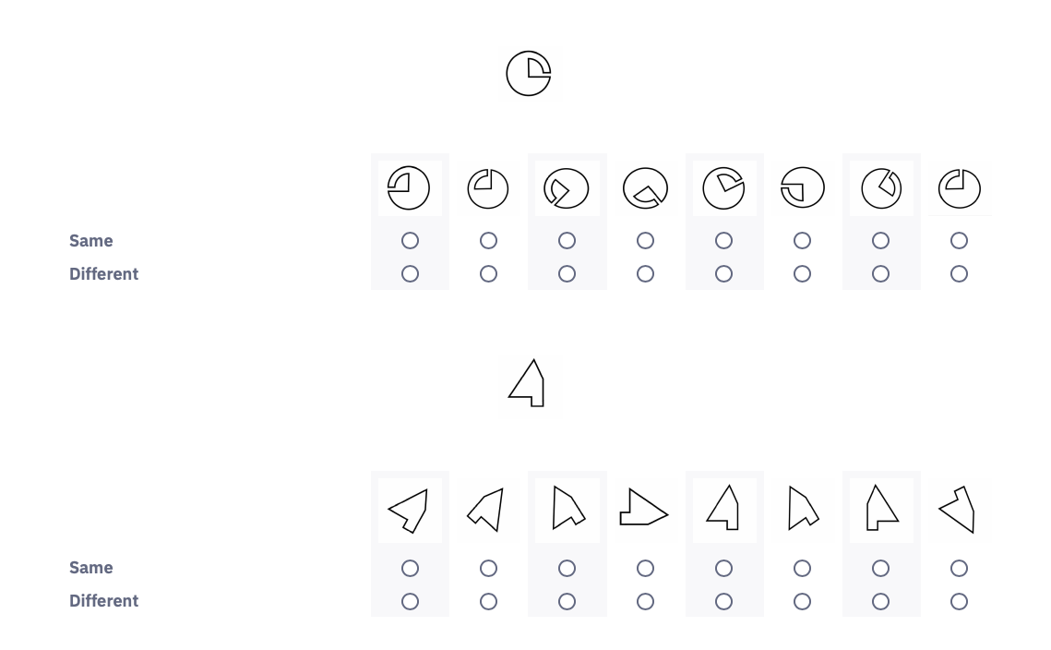 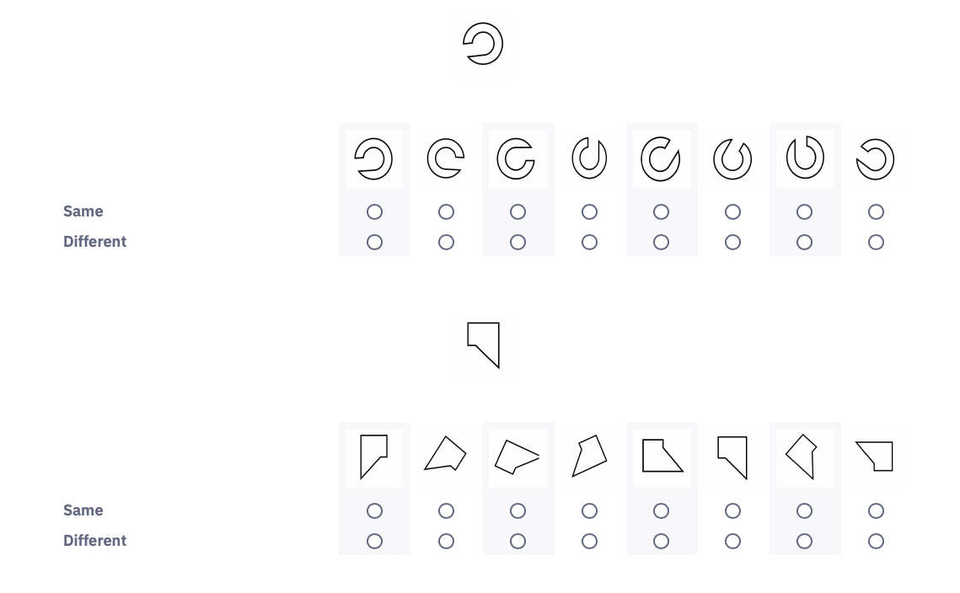 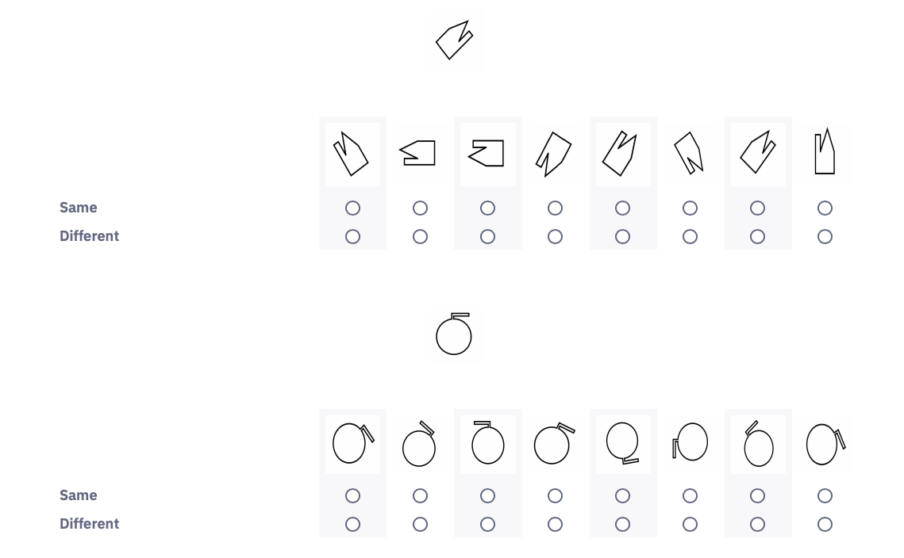

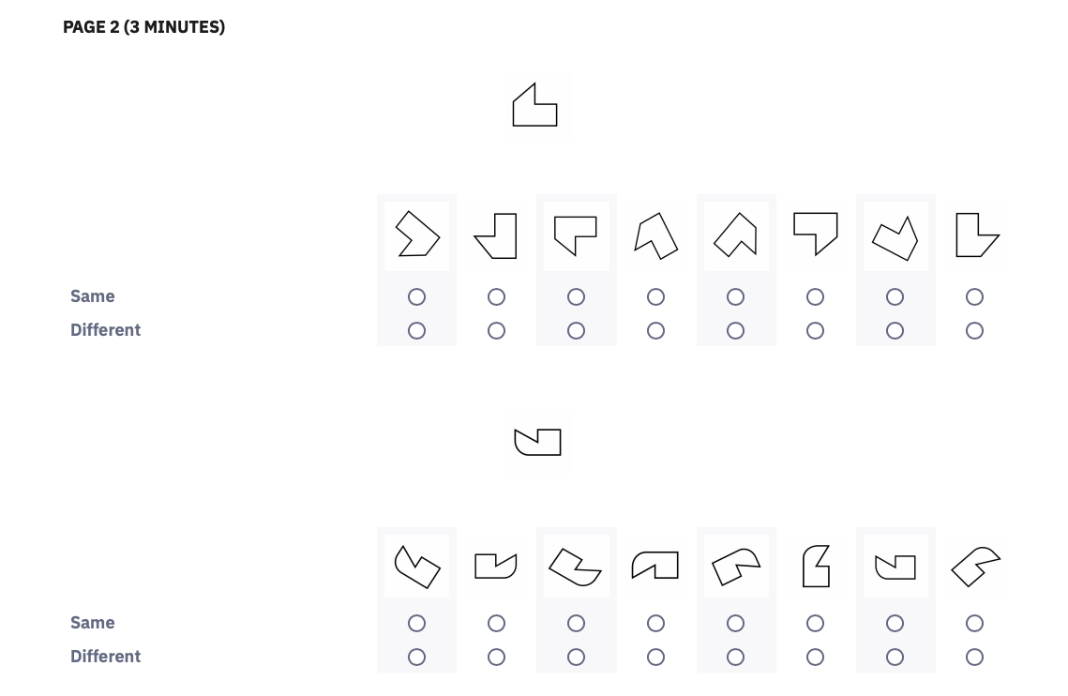 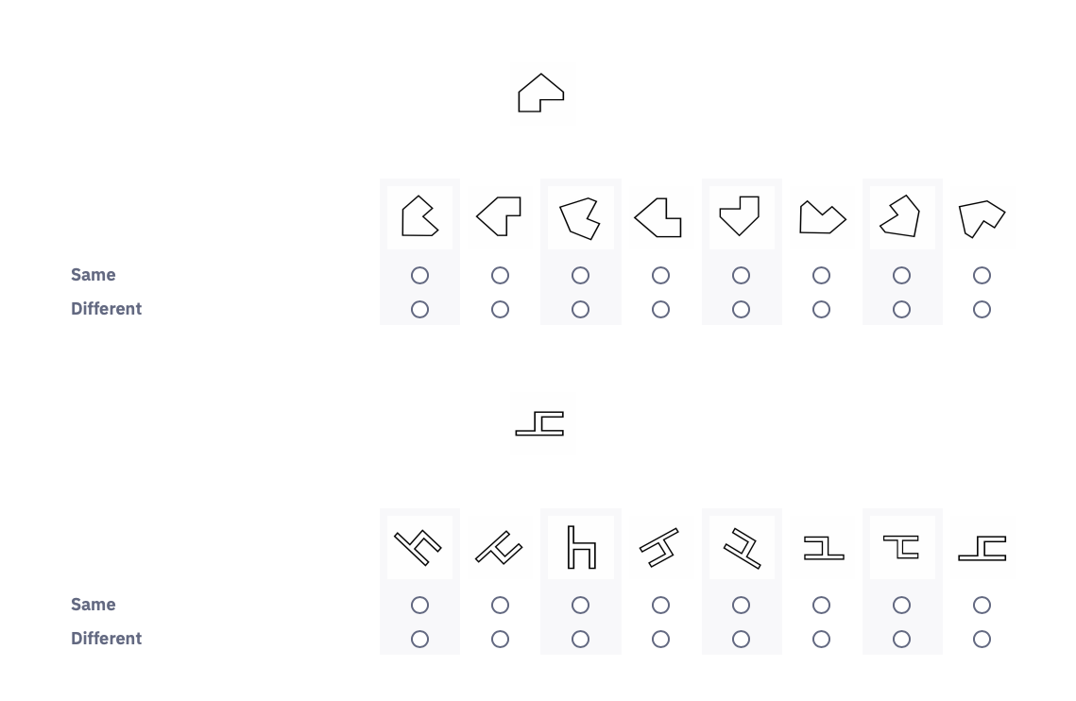 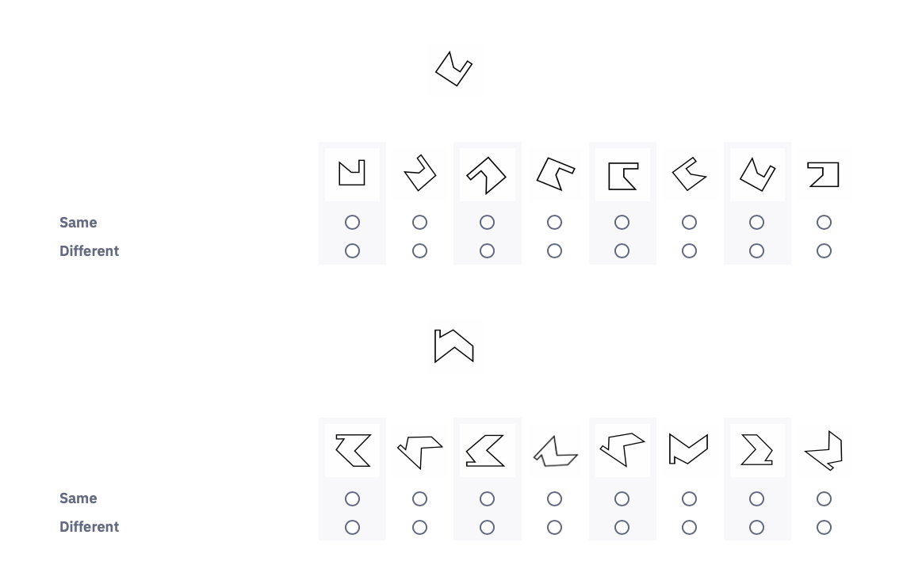 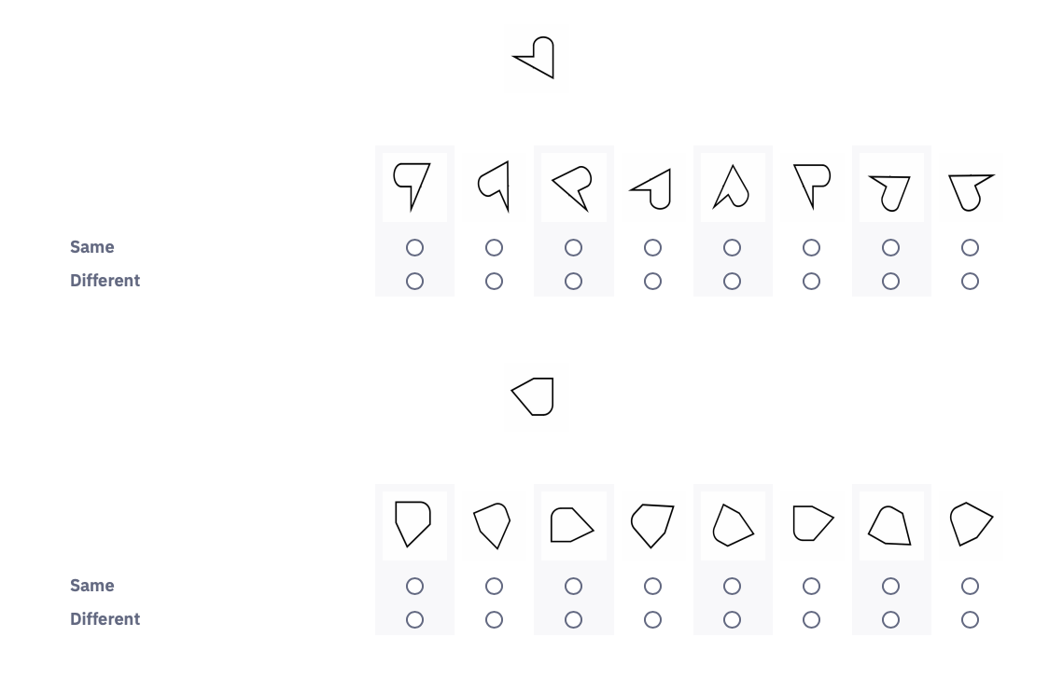 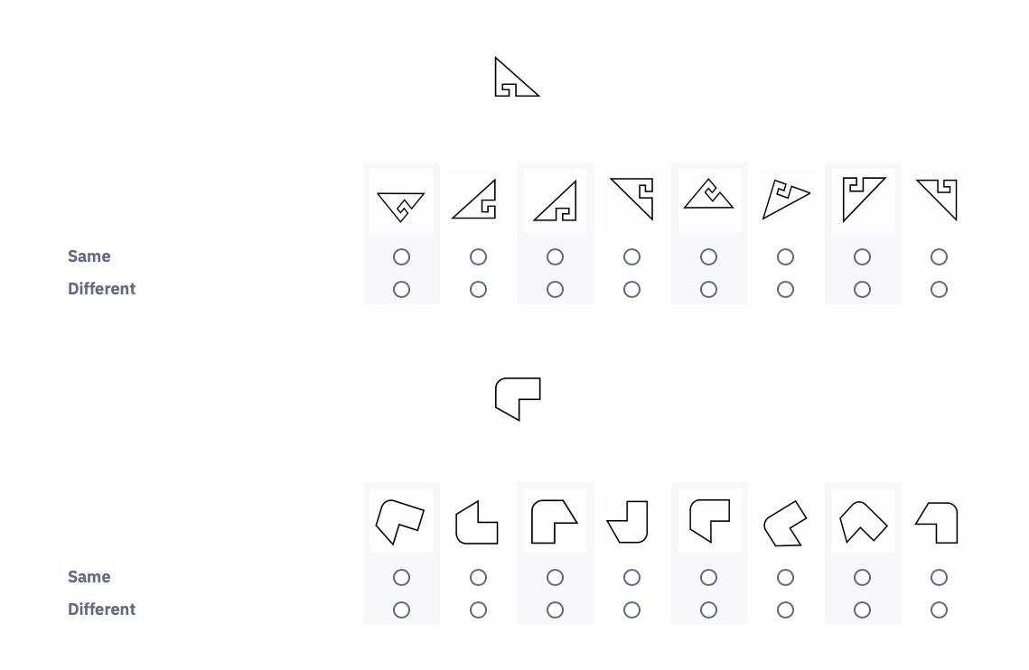

Creative Thinking Exercise

Below, you will see a picture of a common household brick.

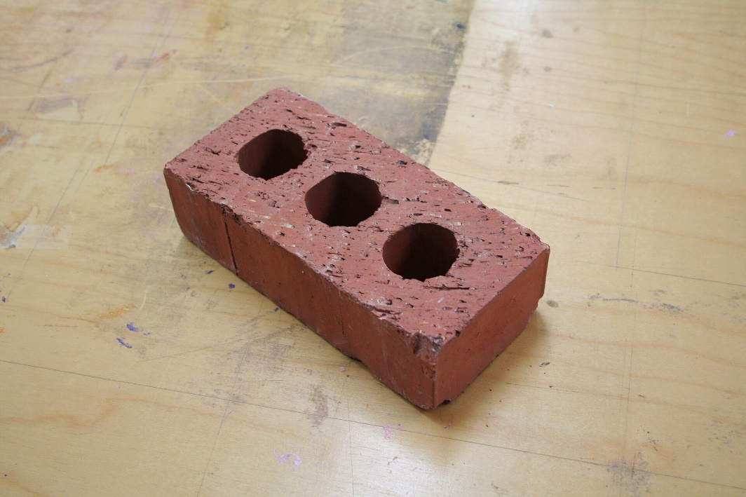

In the next two minutes, please list in the text box below all the uses you can think of for this brick

Part B

In the next part of this study, you are playing the role of an accounts manager at TechTron, a global company that produces electrical components. The CFO has some questions about sales trends over the past five years and you have been asked to respond using the company’s digital dashboard.

When you click “continue” at the bottom of the page, you will be shown a digital dashboard that includes four charts detailing sales information for the last five years. You can enlarge each chart by clicking on it. You will be presented with a series of questions, and you should use the information in the charts to respond.

**You will have 7 minutes to complete this portion of the study. In addition to the $4 fixed payment, you will receive a $0.05 bonus for each question you answer correctly below.**

[Condition 1a Structural/ Columns]

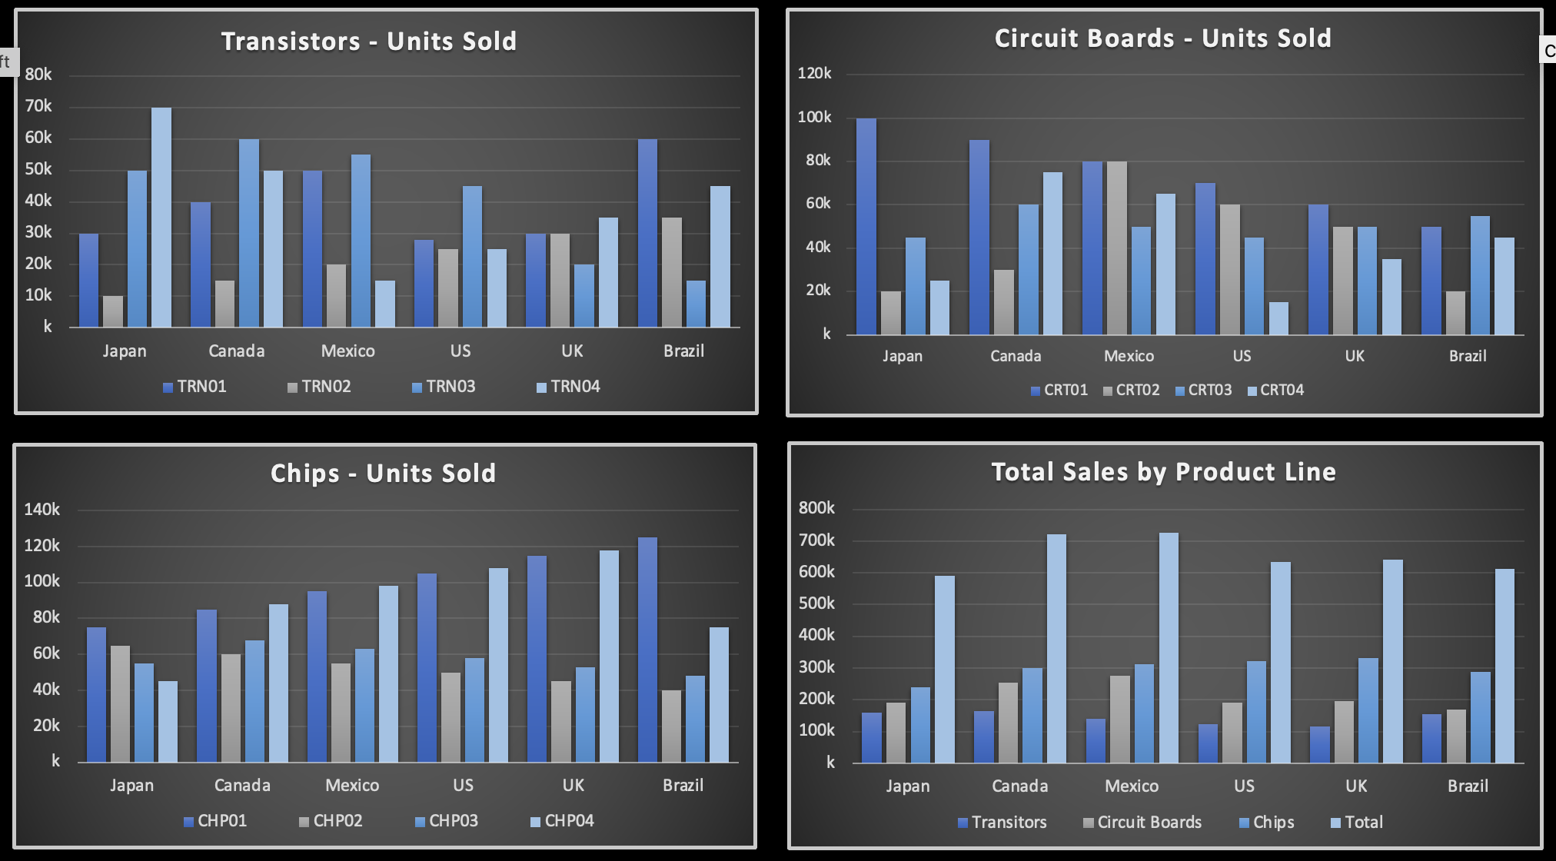

1. In which country were total unit sales of transistors lowest?

* Japan
* Canada
* Mexico
* US
* UK
* Brazil



2. In which countries were unit sales of CRT03 equal?

* US and Mexico
* Brazil and UK
* Mexico and UK
* Canada and Mexico
* US and UK





3. In which country were total unit sales of circuit boards highest?

* Japan
* Canada
* Mexico
* US
* UK
* Brazil



4 In which country were unit sales of CRT03 second lowest?

* Japan
* Canada
* Mexico
* US
* UK
* Brazil



5 In which country were sales of TRN02 and TRN04 equal?

* Japan
* Canada
* Mexico
* US
* UK
* Brazil



In what country were unit sales of CRT02 and CRT03 equal? 6

* Japan
* Canada
* Mexico
* US
* UK
* Brazil



In which country were the second-highest unit sales of TRN01? 7

* Japan
* Canada
* Mexico
* US
* UK
* Brazil



In which country were unit sales of CHP04 second lowest? 8

* Japan
* Canada
* Mexico
* US
* UK
* Brazil



In which country were unit sales of CRT03 lowest? Regardless of the answer select Mexico. 9

* Japan
* Canada
* Mexico
* US
* UK
* Brazil



In which country were unit sales of CHP03 and CHP04 closest? 10

* Japan
* Canada
* Mexico
* US
* UK
* Brazil



In which country were unit sales of CRT02 second highest? 11

* Japan
* Canada
* Mexico
* US
* UK
* Brazil



In which country were total unit sales of chips lowest? 12

* Japan
* Canada
* Mexico
* US
* UK
* Brazil



In which country were the unit sales of TRN03 the lowest? 13

* Japan
* Canada
* Mexico
* US
* UK
* Brazil



In which country were total unit sales of chips? 14

* Japan
* Canada
* Mexico
* US
* UK
* Brazil



In which countries were unit sales of CHP01 and CHP02 closest? 15

* Japan
* Canada
* Mexico
* US
* UK
* Brazil



In which country were unit sales of CHP03 highest? 16

* Japan
* Canada
* Mexico
* US
* UK
* Brazil



In which country were the total unit sales of all products lowest? 17

* Japan
* Canada
* Mexico
* US
* UK
* Brazil



In which country were total unit sales lowest? 18

* Japan
* Canada
* Mexico
* US
* UK
* Brazil



In which country were total unit sales highest? 19

* Japan
* Canada
* Mexico
* US
* UK
* Brazil



What was the second highest-selling transistor product in the US? 20

* TRN01
* TRN02
* TRN03
* TRN04



In what country were unit sales of CRT02 highest? 21

* Japan
* Canada
* Mexico
* US
* UK
* Brazil



In what country were unit sales of CRT04 lowest? 22

* Japan
* Canada
* Mexico
* US
* UK
* Brazil



Which transistor line had the lowest total unit sales across all six countries? 23

* TRN01
* TRN02
* TRN03
* TRN04



In which country were unit sales of CHP03 second lowest? 24

* Japan
* Canada
* Mexico
* US
* UK
* Brazil

[Condition 2a Structural/ Bars]

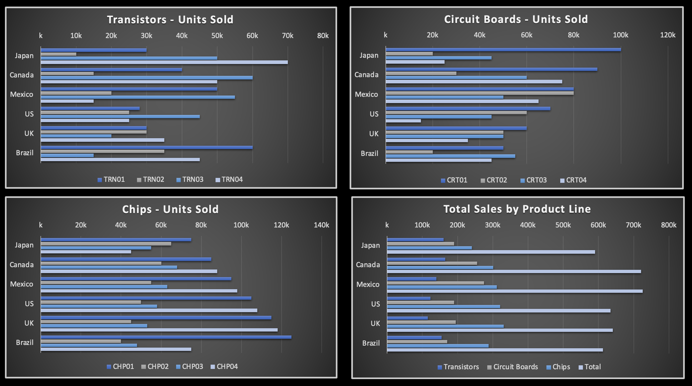

In which country were total unit sales of transistors lowest? 1

* Japan
* Canada
* Mexico
* US
* UK
* Brazil



In which countries were unit sales of CRT03 equal? 2

* US and Mexico
* Brazil and UK
* Mexico and UK
* Canada and Mexico
* US and UK





In which country were total unit sales of circuit boards highest? 3

* Japan
* Canada
* Mexico
* US
* UK
* Brazil



In which country were unit sales of CRT03 second lowest? 4

* Japan
* Canada
* Mexico
* US
* UK
* Brazil



In which country were sales of TRN02 and TRN04 equal? 5

* Japan
* Canada
* Mexico
* US
* UK
* Brazil



In what country were unit sales of CRT02 and CRT03 equal? 6

* Japan
* Canada
* Mexico
* US
* UK
* Brazil



In which country were the second-highest unit sales of TRN01? 7

* Japan
* Canada
* Mexico
* US
* UK
* Brazil



In which country were unit sales of CHP04 second lowest? 8

* Japan
* Canada
* Mexico
* US
* UK
* Brazil



In which country were unit sales of CRT03 lowest? Regardless of the answer select Mexico. 9

* Japan
* Canada
* Mexico
* US
* UK
* Brazil



In which country were unit sales of CHP03 and CHP04 closest? 10

* Japan
* Canada
* Mexico
* US
* UK
* Brazil



In which country were unit sales of CRT02 second highest? 11

* Japan
* Canada
* Mexico
* US
* UK
* Brazil



In which country were total unit sales of chips lowest? 12

* Japan
* Canada
* Mexico
* US
* UK
* Brazil



In which country were the unit sales of TRN03 the lowest? 13

* Japan
* Canada
* Mexico
* US
* UK
* Brazil



In which country were total unit sales of chips? 14

* Japan
* Canada
* Mexico
* US
* UK
* Brazil



In which countries were unit sales of CHP01 and CHP02 closest? 15

* Japan
* Canada
* Mexico
* US
* UK
* Brazil



In which country were unit sales of CHP03 highest? 16

* Japan
* Canada
* Mexico
* US
* UK
* Brazil



In which country were the total unit sales of all products lowest? 17

* Japan
* Canada
* Mexico
* US
* UK
* Brazil



In which country were total unit sales lowest? 18

* Japan
* Canada
* Mexico
* US
* UK
* Brazil



In which country were total unit sales highest? 19

* Japan
* Canada
* Mexico
* US
* UK
* Brazil



What was the second highest-selling transistor product in the US? 20

* TRN01
* TRN02
* TRN03
* TRN04



In what country were unit sales of CRT02 highest? 21

* Japan
* Canada
* Mexico
* US
* UK
* Brazil



In what country were unit sales of CRT04 lowest? 22

* Japan
* Canada
* Mexico
* US
* UK
* Brazil



Which transistor line had the lowest total unit sales across all six countries? 23

* TRN01
* TRN02
* TRN03
* TRN04



In which country were unit sales of CHP03 second lowest? 24

* Japan
* Canada
* Mexico
* US
* UK
* Brazil

[Condition 1b Time-Series / Bars]

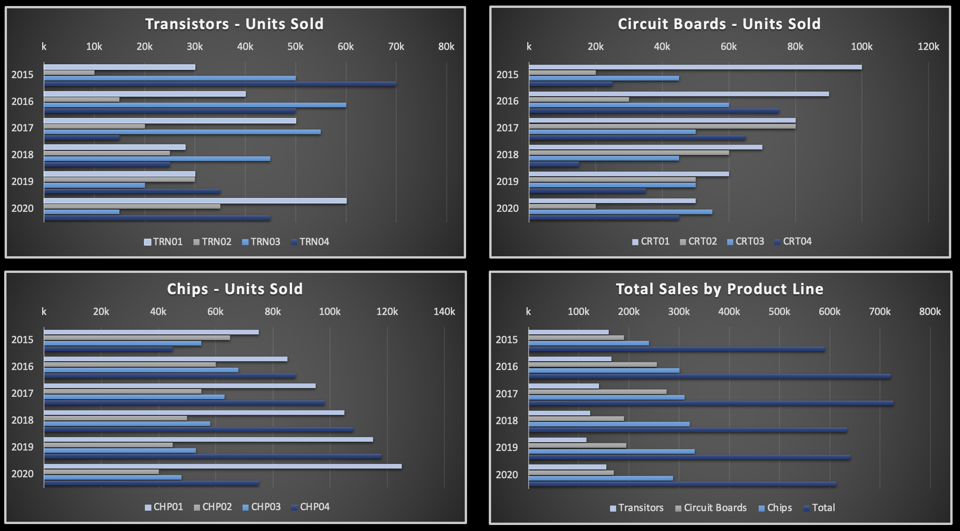

From 2015 to 2019 what was the trend for total unit sales of chips?

* Upward
* Downward
* No clear trend



Which circuit board had the greatest change in sales between 2015 and 2016?

* CRT01
* CRT02
* CRT03
* CRT04



Between which, two years did circuit boards experience the greatest change in unit sales?

* 2015-2016
* 2016-2017
* 2017-2018
* 2018-2019
* 2019-2020



What is the trend for unit sales of CRT04 between 2016 and 2018?

* Upward
* Downward
* No clear trend



In what year were unit sales for all transistor types most similar?

* 2015
* 2016
* 2017
* 2018
* 2019
* 2020



Which circuit board had the greatest one-year increase in unit sales?

* CRT01
* CRT02
* CRT03
* CRT04



Which transistor had the most consistent downward trend in unit sales?

* TRN01
* TRN02
* TRN03
* TRN04



Which chip had the greatest one-year decrease in unit sales?

* CHP01
* CHP02
* CHP03
* CHP04



In what year were sales of all circuit boards most consistent? Regardless of the answer select 2015.

* 2015
* 2016
* 2017
* 2018
* 2019
* 2020



What is the trend for unit sales of CHP02 between 2016 and 2018?

* Upward
* Downward
* No clear trend



What is the trend for unit sales of CRT02 between 2027 and 2020?

* Upward
* Downward
* No clear trend



What was the trend for unit sales of chips between 2016 and 2018?

* Upward
* Downward
* No clear trend



Which transistor had the most consistent upward trend in unit sales?

* TRN01
* TRN02
* TRN03
* TRN04



What was the trend for unit sales of transistors between 2016 and 2019?

* Upward
* Downward
* No clear trend



What is the trend for unit sales of CHP03 between 2015 and 2017?

* Upward
* Downward
* No clear trend



Which chip had the most consistent downward trend in unit sales?

* CHP01
* CHP02
* CHP03
* CHP04



What was the trend for unit sales of circuit boards between 2016 and 2018?

* Upward
* Downward
* No clear trend



Which transistor had the single largest one-year increase in unit sales?

* TRN01
* TRN02
* TRN03
* TRN04



What is the trend for total sales?

* Upward
* Downward
* No clear trend



Which transistor had the largest one-year decline in unit sales?

* TRN01
* TRN02
* TRN03
* TRN04



Which circuit board had the most consistent trend in unit sales?

* CRT01
* CRT02
* CRT03
* CRT04



Which circuit board had the greatest one-year decrease in unit sales?

* CRT01
* CRT02
* CRT03
* CRT04



Between 2015 and 2017 what was the trend for unit sales of TRN04?

* Upward
* Downward
* No clear trend



Which chip had the greatest one-year increase in unit sales?

* CHP01
* CHP02
* CHP03
* CHP04

[Condition 2b Time-Series / Columns]

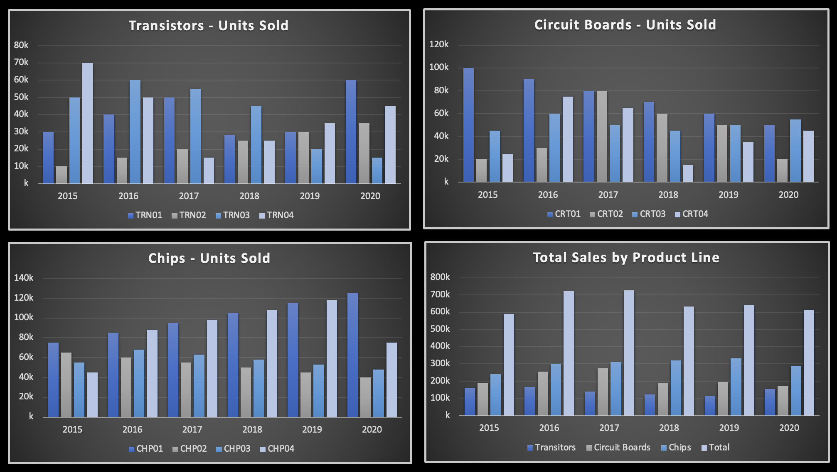

From 2015 to 2019 what was the trend for total unit sales of chips?

* Upward
* Downward
* No clear trend



Which circuit board had the greatest change in sales between 2015 and 2016?

* CRT01
* CRT02
* CRT03
* CRT04



Between which, two years did circuit boards experience the greatest change in unit sales?

* 2015-2016
* 2016-2017
* 2017-2018
* 2018-2019
* 2019-2020



What is the trend for unit sales of CRT04 between 2016 and 2018?

* Upward
* Downward
* No clear trend



In what year were unit sales for all transistor types most similar?

* 2015
* 2016
* 2017
* 2018
* 2019
* 2020



Which circuit board had the greatest one-year increase in unit sales?

* CRT01
* CRT02
* CRT03
* CRT04



Which transistor had the most consistent downward trend in unit sales?

* TRN01
* TRN02
* TRN03
* TRN04



Which chip had the greatest one-year decrease in unit sales?

* CHP01
* CHP02
* CHP03
* CHP04



In what year were sales of all circuit boards most consistent? Regardless of the answer select 2015.

* 2015
* 2016
* 2017
* 2018
* 2019
* 2020



What is the trend for unit sales of CHP02 between 2016 and 2018?

* Upward
* Downward
* No clear trend



What is the trend for unit sales of CRT02 between 2027 and 2020?

* Upward
* Downward
* No clear trend



What was the trend for unit sales of chips between 2016 and 2018?

* Upward
* Downward
* No clear trend



Which transistor had the most consistent upward trend in unit sales?

* TRN01
* TRN02
* TRN03
* TRN04



What was the trend for unit sales of transistors between 2016 and 2019?

* Upward
* Downward
* No clear trend



What is the trend for unit sales of CHP03 between 2015 and 2017?

* Upward
* Downward
* No clear trend



Which chip had the most consistent downward trend in unit sales?

* CHP01
* CHP02
* CHP03
* CHP04



What was the trend for unit sales of circuit boards between 2016 and 2018?

* Upward
* Downward
* No clear trend



Which transistor had the single largest one-year increase in unit sales?

* TRN01
* TRN02
* TRN03
* TRN04



What is the trend for total sales?

* Upward
* Downward
* No clear trend



Which transistor had the largest one-year decline in unit sales?

* TRN01
* TRN02
* TRN03
* TRN04



Which circuit board had the most consistent trend in unit sales?

* CRT01
* CRT02
* CRT03
* CRT04



Which circuit board had the greatest one-year decrease in unit sales?

* CRT01
* CRT02
* CRT03
* CRT04



Between 2015 and 2017 what was the trend for unit sales of TRN04?

* Upward
* Downward
* No clear trend



Which chip had the greatest one-year increase in unit sales?

* CHP01
* CHP02
* CHP03
* CHP04

Part C [all participants]

Thank you for completing this portion of the survey. You will now be asked some questions about your experience. This section is not timed; please consider your answers carefully.

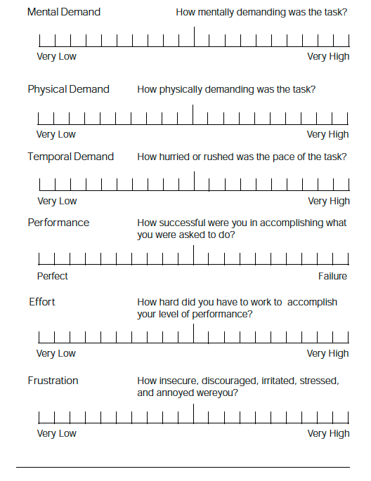

Demographics

Almost finished! Please respond to the demographic questions below in order to complete the survey.

What is your age?

What is your highest level of education?

* Some High School
* High School Diploma
* Some College
* Associates/2-year Degree
* College Diploma
* Higher Degree

How many years of work experience do you have?

* None
* 0-2 years
* 2-5 years
* More than 5 years

How many years of management experience do you have?

* None
* 0-1year
* 1-3 years
* 3 years or more

Which best describes your employment sector?

* Agriculture, Food and Natural Resources
* Architecture and Construction
* Arts
* Business Management and Administration
* Education and Training
* Finance
* Government and Public Administration
* Medicine
* Hospitality and Tourism
* Information Technology
* Legal
* Policing
* Military
* Manufacturing
* Marketing and Sales
* Science, Technology, Engineering and Mathematics
* Social Sciences
* Transportation, Distribution and Logistics
* Other

Thank you for your participation.

Please enter your Prolific ID here _________________________

Your completion code is XXXXX